Why we are giving free support
 | A Royal Commission finds out the truth about important things
 | It can then tell the government what should change
 | There is a Royal Commission finding out about the bad things that sometimes happen to people living with disability
 | We call this the Disability Royal Commission or the DRC
 | The DRC has listened to stories from people with disability
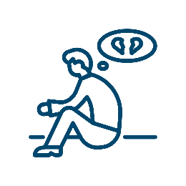 | It knows people with disability don't always get support when they have been abused or not looked after
 | The DRC says this is not okay
 | The DRC wants to find support for people who have had bad things happen
 | It will make sure the same bad things don’t happen to other people
 | You can get counselling if bad things have happened to you
 | Counselling is where you talk with a counsellor
 | Counselling can make you feel better
 | It is free
 | You can get counselling face-to-face
 | You can get counselling over the phone
 | You can get counselling online

