Consent Form
 | Relationships Australia wrote this
 | It’s about how we use your information
 | We write down things like your name and phone number
 | We write down how we can support you
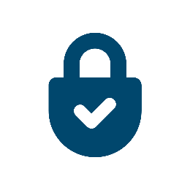 | We keep your information safe
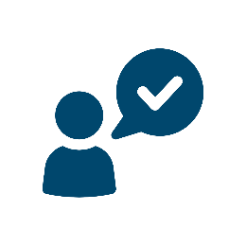 | We don’t share it unless you say we can
 | We might share some information with the government
 | We won’t share your name or personal details
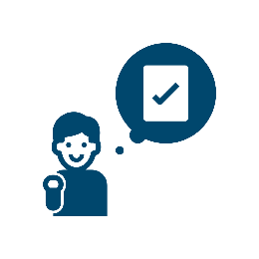 | We might share some information with people who check we’re doing a good job
 | We won’t share your name or personal details
 | You can say you don’t want this to happen
 | We want to make our service better
 | To do this, sometimes a boss will watch our session
 | They will do this by computer
 | We will tell you if we want this to happen
 | You can say no
 | You can change your mind about these things at any time
 | You can get more information on our website at tas.relationships.org.au
 | You can call us on 1300 364 277
 | You can email us at admin@reltas.com.au

Agreement

l understand this information and know how to get more. | - Yes | - No
Relationships Australia Tasmania can collect my personal information. | - Yes | - No
Relationships Australia Tasmania can contact me:  - to ask what I thought about their service  - for research. | - Yes | - No
Relationships Australia Tasmania can share my information (but not my name or file notes) with people who check we’re doing a good job. | - Yes | - No
A supervisor can watch my session. | - Yes | - No
I know I can change my mind about these things, at any time. | - Yes | - No

Your name:

Your signature:

Date:

